\\\\
The Langley Hill Friend
ELEVENTH Month 2011 #486

At the time of greatest darkness
there is the greatest felt need
for celebration,

for the flickering illumination
of candles reaching into the world’s
dark places,

for the ordinary, homely, miracles that
stand against disaster, destruction
and despair,

for the small, sturdy symbols
of inextinguishable hope that
encourage us
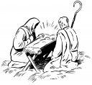
not to mistrust the strength
of the gentle, the decent,
the comic, the kind,

for ritual words that give shape
to shared memory, carrying with them
believable promise,

for laughter that snuffs our fear,
and for an irrepressible merriment
obliterating darkness.

© Carol A. Armstrong, 2007

Calendar

Recurring Events
Sundays 9:00-9:45 am: “Drop-in” Worship Sharing in the upstairs room.
Sundays 9:30 am: Early worship in the meeting room.
Sundays 10 am: Meeting for worship each first day (except the second, when meeting for worship begins at 9:30 to allow a full hour of worship before the business meeting)
First Sundays: 9:15 am: Singing ♪♫. 10:00 Worship. 11:00 Fellowship. Noon Potluck.
Second Sunday: 10:30-12:00 noon - Meeting for worship with a concern for business.
Third Sundays: 7:00-9 pm: Adult Discussion.
Saturdays 12-1 pm: Witness on the Mall with "Seek Peace and Pursue It" banner. (Contact Bill Mims 703-281-7293)

Upcoming Events -- See Next Page for Second Hour schedule
12/28 Wednesday Reflections Hike, Friends Wilderness Center – see article.
12/28 Wednesday Video: “The Franklins” sponsored by Working Group on Racism
1/15 Sunday 7-9 pm Third Sunday discussion: “The Pilgrim's Tale,” Ch. 1-4. Translated by T. Allen Smith (Paulist Press)
1/27-29 Fri – Sun Women’s Retreat – see article
3/11 Saturday 10am – 7pm Interim Meeting, Charlottesville
To Schedule Second Hours, contact: Jeanne Houghton 703-609-1065
For other uses of Meeting House contact Virginia Colin 703-864-2101


Friends Drop-Ins –
9 AM Sundays – Gathering Room

25 December: Christmas reminiscences & stories
1 January: Queries, Advices, and Voices on Simplicity from the Draft BYM Faith & Practice
8 January: Travels, Sufferings, and Persecutions of Barbara Blaugdone (1691)
15 January: The Naylor Sonnets by Kenneth Boulding, sonnets XIV and XV

Second Hours – Sundays
11 AM (after announcements)
12/25 Fellowship
1/15 Spiritual State of Meeting discussion
1/22 Intergenerational Worship Sharing
1/29 Meeting Communications discussion
2/19 Video: “The Franklins” (concerns slavery)
2/26 Peace Corps Anniversary
The first Sunday is always Fellowship followed by potluck; second is Business Meeting. Thus there are only two (occasionally three) possibilities each month for special programs.

On Writing a Christmas Play
with Children

Our 3rd – 6th Sixth Grade First Day School Class has been writing a Christmas play about listening and giving. There’s a legend passed down in Carols that on Christmas eve the animals could talk; and in keeping with our desire to weave in Quaker values, our class has been doing a riff of that legend with George Fox’s sense that if we really listen, every day can be like Christmas.
But how do we really listen?
We open the play by having George Fox say: “ if you are quiet and you listen very still, you can listen to animals.”
One boy shook his head and responded: “I tried that with my cat and it didn’t work.”
We queried: “But did you really listen?”
A girl said, “My cat says, ‘I want fish’.
A teacher probed: “That’s the first answer. Now, go deeper.”
Another boy thought for a moment and spoke up, “I imagine that I take my cat to an empty room. Then I concentrate on something that is very difficult to understand. Eventually my brain gives up and my mind is empty. I let go, and listen. “
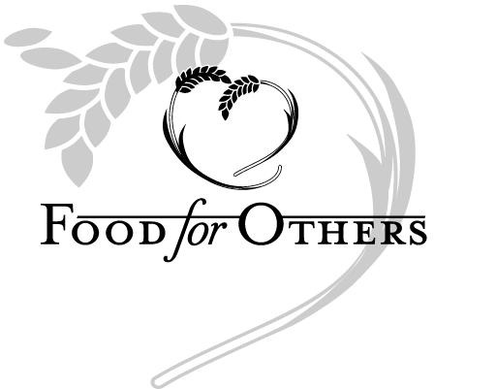
And may we all remember, that we should listen, let the first message go, and then strive to go deeper. And may we all remember that every day is like Christmas.
JMM News

The Power Pack food drive for school age children in Fairfax County collected enough food for 50 daily meals (breakfast, lunch and dinner)! Young Friends met at the Yeaneys' house recently to assemble the food (and buy more necessities from the bake sale funds) into
gallon bags which will now be dropped off for use. Thanks to everyone that contributed groceries or money for this very worthy local need.

~~~~~~~~~~~~~~~~~~

On Thursday, December 29th, Young Friends will go on their annual ski trip to Whitetail. A sleep over is planned the night before at the meeting house so they can get an early start (6:30 AM) to get to the slopes (hopefully there still will be snow). Anyone interested should contact Richard Laity. Young Friends have funds available for anyone who needs financial assistance.
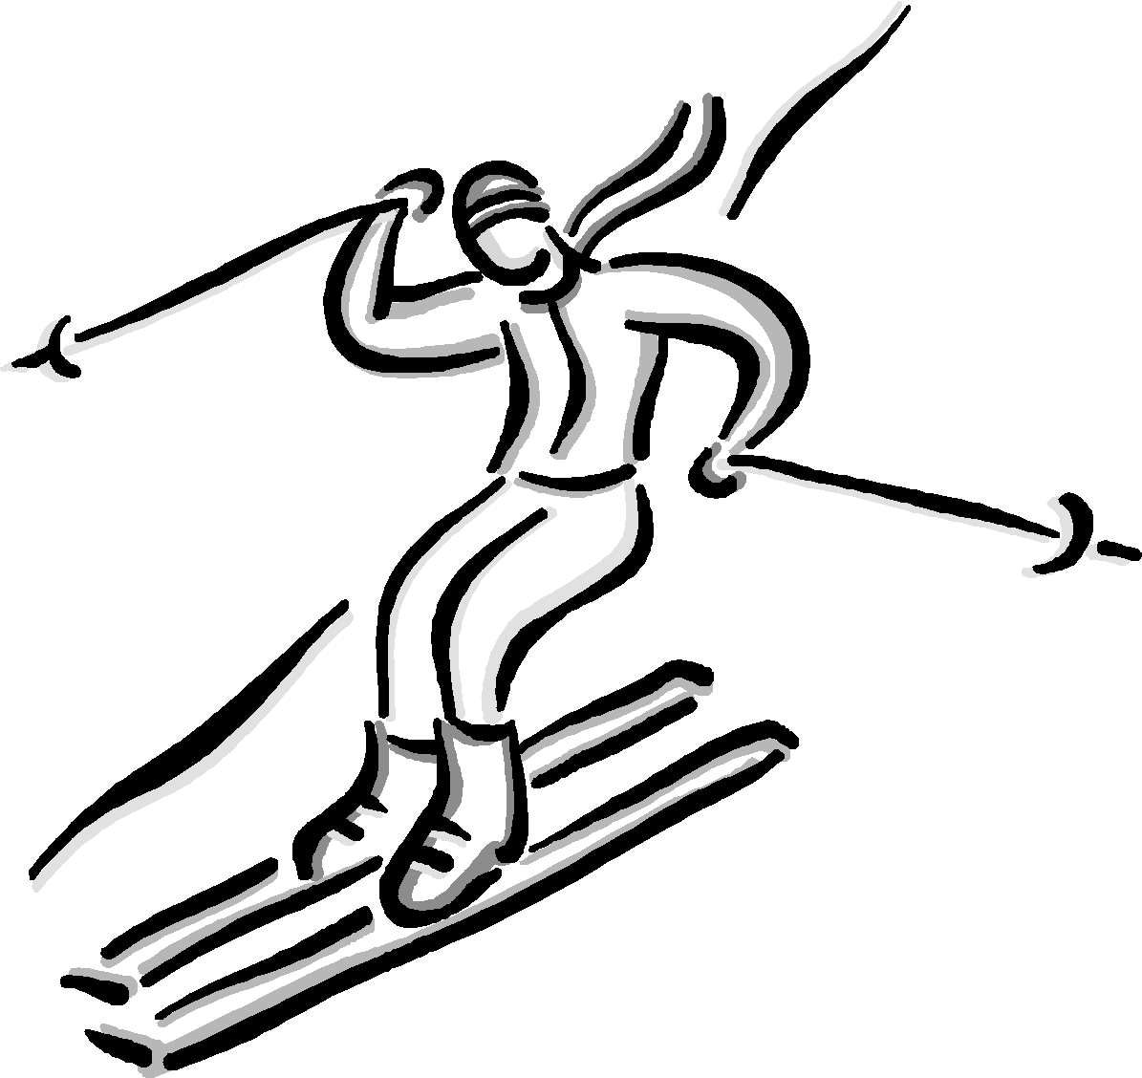
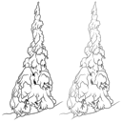

Notes from December Business Meeting

Finances, nominations, Ministry & Worship, and communications were the major topics.
Finances are – as always – in good order, but we are critically behind our goal for non-AutoGive contributions. Autogive does not replace our need for regular contributions. If friends give $12,000 by the end of the year, we will be back on track to meet the budget we approved last spring. So Friends are urged to give generously right now, and incidentally to reap the benefit of a tax deduction.
We approved the nominations of Mary Yeaney as Meeting Clerk and Ollie Moles as corresponding clerk. The Committee is deeply appreciated for their extensive and ongoing work this year.
The Annual Report from the Ministry and Worship Committee is in this newsletter.
Communications within the Meeting was a major topic of discussion, starting Paul Slatery’s report of the communications group (Paul, Doug Neal, Jeanne Houghton so far). Their focus is not just on technology ( though that’s critical) but on how we come to know each other and weave the network of our spiritual community. The channels we have – Sunday announcements, meetinghouse bulletin board, newsletters (print & online), websites (private Yahoo & public via BYM), Facebook group, listserve, telephone, and just plain talking with each other – are used inconsistently and none reaches everyone. Some are uncomfortable with electronic information; and need paper. Some prefer one channel, some another. For instance, the RE people downstairs don’t hear announcements and feel disconnected from the community. There’s a subtle undercurrent that “people just know things”, but new and newer comers don’t. Some are information gaps; some are gaps in the web of our community. The work on these issues continues. There will be more reports – and information is eagerly awaited from anyone who sees a problem or a solution. One problem was solved while we met: we learned that JMM folks use texting, which solves the problem of communication between adults and the kids.
~~~~~~~~~~~~~~~~~
PS. In discussion of the M&W report, a friend reported hearing some disgruntlement about issue of bringing drinks other than water into meeting for worship. From this former member of M&W when the situation was discussed, I’d like to say that we never intended to set a rigid rule that would offend anyone. We did hope to encourage those bring drinks into worship to consider not doing so in order to respect the sensitivities of others who find it distracting. On the other hand, those who find drinks in meeting inappropriate are gently asked to soften their response and appreciate the efforts of those giving up the practice to honor our sensitivities. The only goal is to enhance everyone’s ability to be completely present to the Spirit during worship. We come together to worship and to appreciate and support the Light within each other.



BYM Women’s Retreat
27–29 January 2012 Skycroft Conference Center

Registration is still open. Scholarships are available. Go to the BYM website, click on Women’s Retreat on the right, and you’ll see a link to registration.
Reflection Hike at
Friends Wilderness Center
December 28 – Wednesday

It’s the season of peace, so would you like to go some place beautiful and find tranquility? Would you like a bit of clean, fresh air to go with that? Send out the old year with some clarity and some gratitude. The day will begin at 10:00 am. Suggested donation is $10.00 per person. For more information, contact Sheila Bach. (304-728-4820 or snbach@earthlink.net)



Ministry and Worship Committee
Annual Report for 2011-12

The Ministry and Worship Committee oversees and nurtures the spiritual health of the community. We have met this year in the evening hours in the peaceful atmosphere of the Meeting's Gathering Room. Our agenda each month includes time for considering the quality of worship during the previous month. As the year progressed, we noticed our hearts softening toward the variety of messages that arise in vocal ministry. We desired to balance our commitment to vocal ministry as arising out of a divine leading with an open-minded recognition of the many ways in which the Divine can speak to and through us.
The Committee faithfully fulfilled its responsibility to find greeters and risers for each week's Meeting for Worship and updated the guidelines for these roles including reminding Friends not to bring beverages into Meeting for Worship unless necessary.
In taking responsibility for writing the Spiritual State of the Meeting report sent each year to Baltimore Yearly Meeting, we again facilitated a second hour to which all Langley Hill attenders were invited. For this second hour, we used the excellent queries developed by BYM as a foundation for meaningful worship sharing and the creation of the final report.
An additional second hour was used for careful consideration of Baltimore Yearly Meeting's draft vision statement prepared by their ad hoc committee of traveling ministers.
We held a retreat early in 2011 to share with each other our visions for the Ministry and Worship Committee and our particular interests and concerns. Out of this retreat, we developed a list of goals for this year which have served to direct our energies where they seemed most needed. These goals organized themselves into four main areas.
1. Thinking about our children: In exploring possibilities, we met with representatives of the Religious Education Committee and out of this dialogue grew a decision to have an RE facilitated "Family Worship" on second First Day between 10 and 10:30 AM in the Gathering Room. This has been going well and various challenges are being worked out as they arise.
2. Outreach ideas: Two sub-activities of Ministry and Worship, each with their own committee, have been active this year: The Advancement and Outreach Committee successfully developed a working system for nametags that has increased our ability to know each other's names as more people wear them and to relate more personally with newcomers. The Working Group on Racism has held several events for the purpose of heightening our awareness of the ongoing realities of racism and white privilege.
3. Introduction to Quakerism: Using a small but comprehensive book by Pink Dandelion on the history of the Society of Friends, we conducted a series of Sunday night discussion and worship sharing groups in June. These were well attended and greatly enriched by the attendance of some members who have a long history with the Society of Friends.
4. Friendly Interest Groups and other community building activities: Some of these have already been in existence and a number have been added throughout the year. Among these activities and groups, most of which are open to new participants are: A Drop-in Worship Sharing Group on Sunday mornings at 9 AM this fall with varied Quaker readings and discussion topics growing out of a Bible Study group that met at that hour; third Sunday evening discussion groups on a variety of Quaker-related topics; a Gospel of John study group; mid-week monthly meetings for worship sharing based on queries; family game nights, and a movie-watching group. One of the tasks that we took on this year is to oversee the careful study of the newly revised, draft "Faith and Practice" book published by Baltimore Yearly Meeting. We committed one of the 3rd Sunday evening discussion groups to a study of the first sections of the book. Following that, the Meeting's many standing committees have been invited to review the queries and advices that are relevant to their particular missions and tasks and to send them to the Ministry and Worship Committee to organize and pass on to the BYM committee overseeing this important effort.
One of our Committee's major responsibilities and privileges is to assist with memorial meetings, weddings, and holiday events as needed. We helped facilitate the annual Thanksgiving Meeting for Worship and potluck dinner. And we organized (with the creative assistance of many Friends) a 24 hours of Christmas celebration that ends with our traditional candlelight service. When long-time Friend and member, Pat Moles died in July, we worked closely with her family to create a memorial meeting that allowed us to both grieve and celebrate her in loving community with one another. We were also blessed by participation in the marriage celebration of member Susan Hills and Jim Rose.
It has been a year of holding each other in the light as we work together to do the same for the Meeting. We are grateful to be both nurturer and nurtured in this process.
Committee: Maryhelen (Mel) Snyder, Clerk, Jim Fussell, Jeanne Houghton, Tim Hunt, Juliet Isele, Bill Mims, Steve Morse, Jenepher Moseley
Ann Stone

Thinking about Race: What is accountability?


“Participating in solidarity work implies that I am not from the community in which I am working, that I have skills or privilege to offer, and that I am constantly and consciously working towards developing others’ leadership and access to resources. This process includes political advocacy, building valuable relationships, reallocating resources, being transparent in my actions, and being strategic and sustainable with my energy. The key word – accountability – means recognizing that this work is about supporting folks and their projects [in that community] in a way that is not about me and my involvement, but is about the people directly affected and the way they wish to express their needs and greatest potential.”

From the 2010 book, Accountability and White Anti-racist Organizing: Stories from Our Work, chapter one by Jacqui Hermer, “Lessons from Post-Levee-Break New Orleans.”

The Baltimore Yearly Meeting Working Group on Racism meets most months on the third Saturday from 10:00 am to 1:00 pm, at Bethesda Friends Meeting or Friends Meeting of Washington. If you would like to attend, on a regular or a drop-in basis, contact clerk Elizabeth DuVerlie at eduverlie@jhu.edu.

NOTE: Friends who wish to comment on this or any other “Thinking About Race” items, may do so at http://racism.bym-rsf.net. To leave comments, register first by emailing webmanager@bym-rsf.net.

Learning and Feeling Connected – on Racism
Babs Williams

I've been participating in the Langley Hill Working Group on Racism (WGR) for the past few years and I've learned a lot about myself and how I feel about racism. Recently I attended a documentary that moved me to learn more and do more. It is called “The House We Live In” which is part of the Smithsonian's exhibit on “Race – The Power of Illusion”. The exhibit and film was brought together mainly by leading anthropologists and sociologists making the point that all humans are genetically alike and that the concept of race is a social construct. There is no subspecies of human beings.

The film documents that race is based on our cultural lens, which comes from systematic discrimination of people of color through out our history and into the present time. This “social construction” was set up with a system of “racial markers” to insure “racial inequities” which were made into our laws. This system goes back to the founding of our nation. Laws were put into place to remove Native American peoples from their land and set up reservations on which they were forced to live. As immigrants came over to the US looking for freedom and new opportunities, but they were given the lowest paying most dangerous and difficult jobs, such as factory workers, miners and agricultural workers. As Jewish, Russian, Asian and other people of color immigrated, laws were put in place to define which groups of people were “white”. The more light skinned people were labeled white and they were privileged to obtain opportunities to move ahead. Under the law of the land Africans were brought over and sold as slaves to work on white people's land and in their houses.

In 1865 the 13th Amendment of the Constitution was passed, abolishing slavery. This occurred after the Civil War, in which many people of African descent fought. Still, people of African descent and other people of color could not be citizens of the U.S., which meant they had no protection under the law and no rights to own land or start their own business. During this period of time the supreme court ruled that only white men could be U.S. citizens, and even if a person had 1/16th of African ancestry they were denied citizenship. In 1868 the 14th Amendment was passed which states that racial requirements would be removed as a requirement for citizenship. The film also shows that the right to vote regardless of racial identity wasn't put into law until the 15th Amendment was passed in 1870, which states that a “man” could not be denied the right to vote based on his racial identity. (Women couldn't vote until 1920.)

Over time, despite these legal advancements, people of color particularly those of African ancestry continued to be relegated to the poorest areas, attending the most disadvantaged schools, and wound up in the lowest paying jobs with no health care. After serving in WWI and WWII, African Americans came home and were denied the advantages that whites were afforded. Laws were in place to restrict people of color from receiving Veterans benefits and FHA loans. Without the ability to purchase homes, African Americans were barred from reaping the benefits afforded to whites . Homeownership was the main way that families were and are able to move up in America. They were and are given tax breaks and the equity in their homes qualifies them for loans so they can send their children to college. Then at the end of their lives, their children are able to inherit their parent’ wealth. Social Security was not available to domestic and farm workers, (mostly African Americans) which was needed to have a retirement benefit to help cover elder expenses. So generations of “whites” received these privileges and prospered.

In the meantime people of color, mostly African Americans, found that they were shut out of these privileges. They were relegated to unstable neighborhoods which were segregated and cut off from the “American Dream”. Under the Federal Housing programs, 2% of Blacks qualified for housing loans, while the other 98% were left with the option to rent or many were placed in public housing located in cities. In 1968 Congress passed the “Fair Housing Act” which stated that neighborhoods had to be integrated. This began the “white flight” from the suburban middle class neighborhoods as large real estate firms “red lined” certain neighborhoods. They played on the fear of whites that blacks could move in and offered them cash for their homes. Then they turned around and sold or rented to black families for higher prices, bringing about further segregation.

Many African Americans are continuing to be shut out of the mainstream “white” privileges
of education, decent housing and economic stability. We continue to live in a society where
the results of institutionalized racism from the our beginnings are evident today .The white dominant group in the US continues at the top of the power and economic ladder. This is evidenced by the “wealth gap” which states that the average black family has 1/8th of the wealth of the average white family. So this breaks down to the average wealth of white families being $113,000, while the average wealth of black families is $14,000.

The film and discussion afterwards asks us “now that we know about how inequitable our system was and is, what can we do to make our society more equitable for all?”

Some suggestions for getting involved are:
- we need to learn about the history of racism.
- we need to understand that as white people we are privileged in our society and we need to make some changes in order to achieve a more harmonious society.
- we need to support affirmative action.
- we need to work to make our neighborhoods and schools equitable.
- we must advocate for universal health care.

Through my participation in Langley Hill's WGR I have begun to feel connected and excited to be a part of a new multicultural way of being within myself and in the world. I have been inspired to travel to Kenya, meet many Kenyan Friends and learn much from them. Lately I have been moved to become more involved in equality and I'm taking some of the steps mentioned above. It's an exciting journey and I know that I have a long way to go. If you're interested in this study I recommend reading just two books to start, “Fit for Freedom, not for Friendship” by Vanessa Julye and Donna McDaniel and “Lifting the White Veil” by Jeff Hitchcock.

The film “The House We Live In” is available through the Baltimore Yearly Meeting's WGR. Our Langley Hill WGR will make the film available to the Meeting in the spring and offer opportunities for discussion.

This Month in Quaker History

In December of 1675, the colony of Rhode Island had a Quaker governor, and a Quaker majority in its Assembly. These were among the first Friends who held responsible public office, and to have to reconcile their Peace Testimony with the demands of government. This was no easy task for them, as their colony was enveloped in a bloody Indian War beginning in the summer of 1675, called King Philip's War by historians after the chief who was its leading figure. The Quaker officials had managed to maintain peaceful relations with the Indians living closest to them, the Southern Narragansetts. But the other New England colonies didn't trust the Narragansetts, or the Quakers either, And in mid-December, an army of one-thousand soldiers, under the command of Governor Josiah Winslow of Plymouth Colony, marched into Rhode Island territory and on December 19, attacked the Narragansetts' secret stronghold in the Great Swamp.
The Quaker officials protested the invasion of their territory, but to no avail. The army fell on the Narragansett Camp at night, setting it afire and killing many children and infirm older Indians, as well as braves. The attack pushed the remaining Narragansetts into the war on King Philip's side, increasing the danger to Rhode Islanders. But when the battle, known as the Great Swamp Fight, was over, Winslow’s uninvited army marched back out of the colony, leaving the Quaker leadership to face the consequences of the attack.
The Quakers did their best, in a story too long to tell here. They finally yielded to demands to form a militia, but disbanded it as soon as the war was over. And they also maintained as best they could their exemption for conscientious objectors to militia duty, the first legal CO provision anywhere. Despite the difficulties of the war and the hostility their pacifism engendered, Quakers were re-elected to the governorship for many years afterward.

DECEMBER 2011
On Writing a Christmas Play with Children
Young Friends News
Wilderness Center Hike 12/28
December Business Meeting Notes
Ministry & Worship Annual Report
BYM Women’s Retreat
Thinking about Race - Accountability
Learning and Feeling Connected – on Racism
This Month in Quaker History

Langley Hill Friends Meeting
P.O. Box 387
McLean, VA 22101
Address Correction Requested

